

A Project Report on

## “Elixora-Interactive Web-based Skin Care and Makeup Advisor.”

Submitted in partial fulfillment of the requirements for the award of the degree of

### Third Year Engineering

in

### Information Technology

by

|  |  |
| --- | --- |
| **Shravani Khanvilkar** | **(23104220)** |
| **Samiksha Avhad** | **(23104207)** |
| **Anushka Kangane** | **(23104144)** |
| **Rujuta Gujar** | **(23104083)** |

Under the Guidance of

### Prof. Shafaque Syed

**Department of Information Technology**

**NBA Accredited**

A.P. Shah Institute of Technology G.B.Road,Kasarvadavli, Thane(W)-400615

UNIVERSITY OF MUMBAI

**Academic Year 2025-2026**

### CERTIFICATE

This is to certify that the project entitled ***“APSIT DevOps Club: A Web Platform for interacting Students through Collaboration and Innovative Activities.”*** sub- mitted by ***“Shravani Khanvilkar” (23104220),“Rujuta Gujar” (23104083),“Samik- sha Avhad” (23104207),“Anushka kangane” (23104144)*** for the partial fulfillment

of the requirement for award of a degree ***Bachelor of Engineering*** in ***Information Technology*** ,to the University of Mumbai,is a bonafide work carried out during academic year 2025-2026.

Prof. Shafaque Syed Dr. Kiran Deshpande

Guide Guide

External Examiner Internal Examiner

1. 1.

Place:A.P.Shah Institute of Technology, Thane Date:

### Acknowledgement

This project would not have come to fruition without the invaluable help of our guide **Mr. Vishal Badgujar**. Expressing gratitude towards our HoD, **Dr. Kiran Deshpande**, and the Department of Information Technology for providing us with the opportunity as well as the support required to pursue this project. We would also like to thank our project coordinators **Ms. Sonal Jain** and **Ms. Shafaque Fatma Syed** who gave their valuable suggestions and ideas when we were in need of them. We would also like to thank our peers for their helpful suggestions.

# Contents

1. Introduction 1
   1. Purpose . . . . . . . . . . . . . . . . . . . . . . . . . . . . . . . . . . . . . . 1
   2. Problem Statement . . . . . . . . . . . . . . . . . . . . . . . . . . . . . . . . 2
   3. Objectives . . . . . . . . . . . . . . . . . . . . . . . . . . . . . . . . . . . . . 2
   4. Scope . . . . . . . . . . . . . . . . . . . . . . . . . . . . . . . . . . . . . . . 3
2. Literature Review 4
3. Project Design 6
   1. Features and Functionality . . . . . . . . . . . . . . . . . . . . . . . . . . . . 6
   2. System Architecture . . . . . . . . . . . . . . . . . . . . . . . . . . . . . . . 7
   3. DFD (Data Flow Diagram) . . . . . . . . . . . . . . . . . . . . . . . . . . . 8
   4. Use Case Diagram . . . . . . . . . . . . . . . . . . . . . . . . . . . . . . . . 8
4. Technical Specification 9
   1. Front-End (Client-Side) . . . . . . . . . . . . . . . . . . . . . . . . . . . . . 9
   2. Back-End (Server-Side) . . . . . . . . . . . . . . . . . . . . . . . . . . . . . . 9
   3. Development, Operations and Deployment . . . . . . . . . . . . . . . . . . . 9
   4. Development Tools 10
5. Project Implementation 11
6. Project Scheduling 13
7. Results 14
8. Conclusion 21
9. Future Scope 22

References 23

3

### Abstract

Elixora is a sophisticated, interactive, web-based recommendation system designed to deliver highly personalized skincare and makeup product suggestions. Understanding that individual beauty requirements vary widely in terms of skin type, specific concerns, personal goals, and budget, Elixora employs a comprehensive yet user-friendly questionnaire to collect critical user information, including skin characteristics, targeted skincare issues, makeup preferences, objectives, and financial constraints. Leveraging this data, the system generates precise and tailored product recommendations while simultaneously offering features for manual product search, curated list exploration, and in-depth comparison of items based on price, ingredients, brand credibility, and user reviews.

By integrating advanced preference analysis, intelligent filtering algorithms, and an intu- itive, interactive interface, Elixora streamlines the often complex process of choosing suitable beauty products. The system enhances user decision-making by providing relevant, effective, and affordable options that align with individual needs, thereby improving satisfaction and confidence in online beauty shopping. Its adaptive, user-focused approach ensures an engag- ing, efficient, and highly personalized experience, bridging the gap between the expansive array of available products and the unique requirements of each consumer.

Moreover, Elixora exemplifies the transformative potential of intelligent web-based sys- tems in lifestyle and personal care domains. By combining technological sophistication with practical usability, it not only simplifies product discovery but also empowers users to make informed choices, promoting accessibility and inclusivity in beauty shopping. The platform demonstrates how interactive, data-driven recommendation systems can revolutionize the consumer experience, setting a new standard for personalized skincare and makeup guidance in the digital era.

# Chapter 1 Introduction

Elixora is an advanced, interactive web-based recommendation system designed to help users effortlessly discover skincare and makeup products that are tailored to their unique needs and preferences. Recognizing that everyone’s skin type, beauty goals, and budget are different, Elixora provides a smart solution for personalized beauty shopping.

The system works by asking users to fill out a simple and intuitive questionnaire. This questionnaire gathers essential information such as skin type (e.g., oily, dry, combination, sensitive), specific skincare concerns (e.g., acne, aging, dryness, pigmentation), makeup pref- erences (e.g., foundation type, color choices), and individual goals (e.g., hydration, anti- aging, brightening). Additionally, users can input their budget constraints, allowing Elixora to filter and suggest products that are both effective and affordable.

Beyond recommendations, Elixora offers users the flexibility to search for products manu- ally, explore curated lists, and compare items based on ratings, ingredients, and price points. By integrating preference inputs, budget filters, and web-wide product searches, Elixora simplifies the beauty shopping experience, making it smarter, more efficient, and highly personalized.

## Purpose

The purpose of the website is to simplify and personalize the process of selecting skin- care and makeup products for individual users. In the vast beauty market, customers often struggle to find products that match their unique skin types, preferences, and budget. Many products are marketed with broad claims that do not account for individual differences, lead- ing to confusion and ineffective purchases. Elixora addresses this problem by using a simple questionnaire and preference inputs to understand the user’s skin type, concerns, makeup goals, and budget. Based on these inputs, it provides smart product recommendations by filtering options available across the web, ranging from affordable drugstore products to high-end premium brands. The system not only suggests suitable products but also enables users to search and explore products independently, making beauty shopping smarter, faster, and more informed. Ultimately, Elixora empowers users to make well-informed decisions, improving their skincare and makeup routines while ensuring convenience and personaliza- tion.

## Problem Statement

With countless skincare and makeup products available, choosing the right ones can be overwhelming. People have different skin types such as oily, dry, or sensitive that require specific products. The market offers a huge variety of options with similar claims like anti- aging, moisturizing, or acne control, making it hard to know what truly works. On top of that, products range from affordable to luxury, adding budget concerns. Without clear guid- ance, many rely on trial and error or unreliable reviews, which may not suit their individual needs, leading to frustration and poor choices..

## Objectives

* + - 1. Personalized Recommendations Through Easy Inputs : Users input their skin type, preferences, and budget through an easy questionnaire. The system uses smart filters to generate tailored product recommendations.
    - 2. Discover Products Matched to Your Unique Needs : Elixora suggests skincare and makeup products based on individual requirements. It ensures recommendations match skin type, goals, and budget.
    - 3. Simplified and Confident Shopping Experience: The system simplifies product search by providing relevant suggestions. Users can shop without confusion or guess- work.
    - 4. Smart Personalized Recommendation System : An intelligent system recommends the most suitable products for each user. It makes beauty shopping smarter and highly personalized.

## Scope

* + - 1. Specialized Focus on Skincare and Makeup The system is dedicated to recommend- ing skincare and makeup products. It understands the unique needs of beauty and skincare routines. This ensures more accurate and useful suggestions.
    - 2. Reliable and Efficient Shopping Platform Offers a trustworthy platform for discov- ering beauty products quickly. Saves time by eliminating the need to browse countless options. Users get smart recommendations in just a few steps.
    - 3. Personalized Filtering for Better Results Users can filter products by budget, brand, category, and personal preferences. This helps narrow down options to exactly what they need. Making the recommendation process highly relevant and efficient.

# Chapter 2 Literature Review

Elixora system is a personalized web-based platform designed to help users discover skincare and makeup products tailored to their individual needs. It collects user inputs such as skin type, specific skincare or makeup preferences, and budget through a simple, intuitive questionnaire. Leveraging artificial intelligence and machine learning, Elixora processes this information to generate accurate and relevant product recommendations. Similar to recent research in AI-driven beauty technologies, the system can use techniques like computer vision and deep learning models to assess skin conditions such as acne, dryness, or oiliness, enabling precise matching of products to user requirements. Additionally, content-based filtering, which analyzes product ingredients and aligns them with individual profiles, ensures that suggested products are safe, effective, and suitable for each user.

Beyond personalized recommendations, Elixora emphasizes user trust, transparency, and engagement. By incorporating explainable AI, the system provides users with clear reasons for every recommendation, such as ingredient benefits or suitability for specific skin concerns, building confidence in the suggested products. It can also integrate real-time feedback, allow- ing users to rate and review products, which helps refine and improve future recommenda- tions. Combining AI-driven analysis, personalized filtering, ingredient-based evaluation, and adaptive learning, Elixora creates a reliable, efficient, and intelligent platform. It simplifies beauty shopping, reduces confusion and guesswork, and enhances the overall user experience by providing smarter, more informed product choices tailored to individual needs.

]

# Chapter 3 Project Design

## Features and Functionality

* + - 1. Search and Explore Products

Browse skincare and makeup products across multiple categories. Filter by skin type, brand, or concern.

* + - 2. Personalized Product Recommendations

Recommendation engine suggests products tailored to each user. Uses collaborative and content-based filtering to match skin type, preferences, and goals.

* + - 3. Questionaire

The questionnaire is a core component of Elixora that enables the system to provide personalized skincare and makeup recommendations. It collects essential information from the user in a simple and intuitive format.

* + - 4. User Feedback

The user feedback feature is an essential part of Elixora, designed to improve recom- mendation accuracy and personalization over time. After trying the suggested skincare or makeup products, users can provide ratings, reviews, and comments about their ex- perience.

* + - 5. Educational Insights

Provides information on product ingredients and their benefits. Helps users make in- formed skincare and makeup decisions.

* + - Student Connectivity:

The Student Connectivity feature allows students to easily collaborate and stay con- nected with the DevOps club. Through integrated social media channels, students can

also directly reach out to the DevOps team, enhancing peer-to-peer interaction, receiv- ing guidance from mentors, and staying actively engaged with projects and events.

## System Architecture

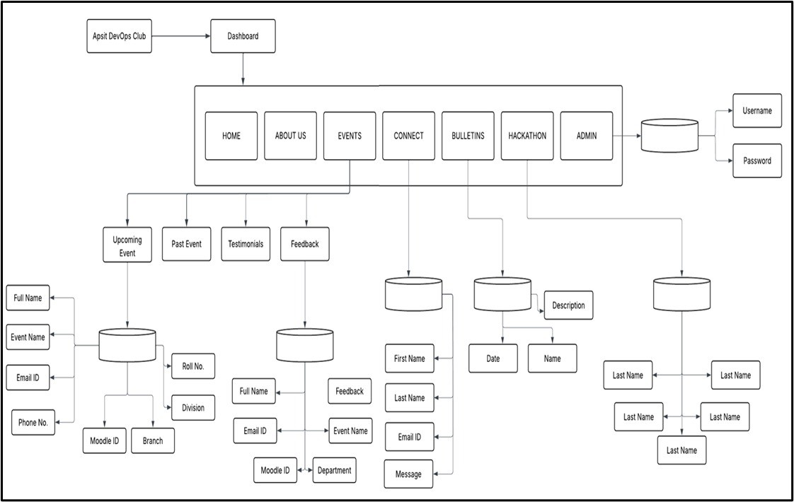

Figure 3.1: System Architecture of APSIT DevOps Club

## DFD (Data Flow Diagram)

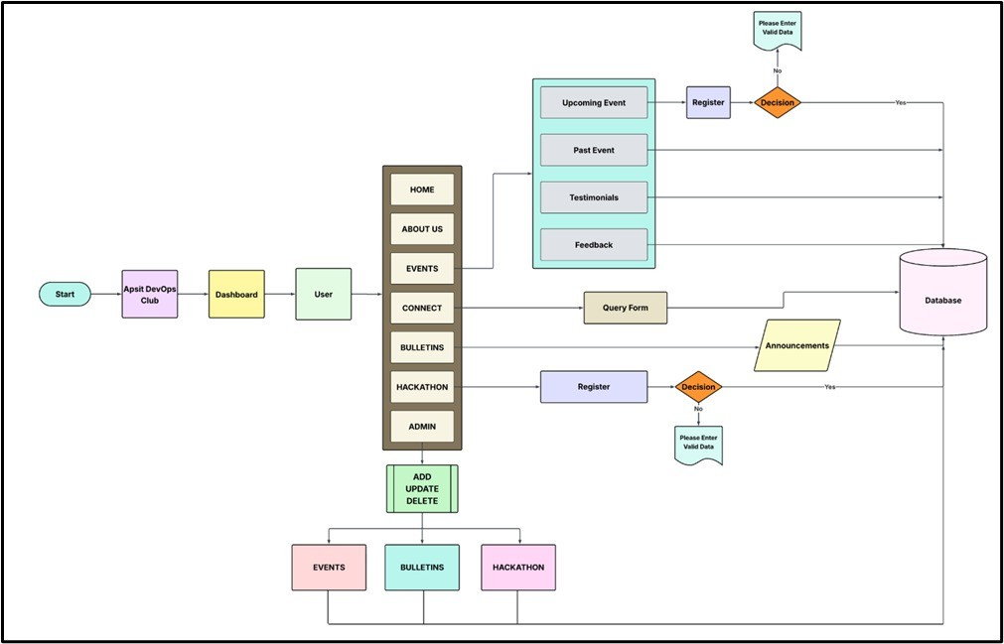

Figure 3.2: Flow Diagram of APSIT DevOps Club

## Use Case Diagram

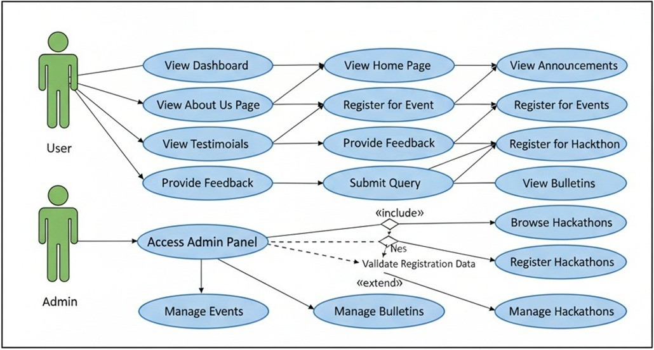

Figure 3.3: Use Case Diagram of APSIT DevOps Club

# Chapter 4

**Technical Specification**

## Front-End (Client-Side)

Core Technologies:

**HTML5 :** Used for structuring the web pages and content.

**CSS3 :** Used for styling the user interface and overall design.

**JavaScript (ES6+) :** Used for creating dynamic and interactive user experiences. **React JS :** A component-based library used to build the user interface (UI) efficiently. **Tailwind CSS :** Employed for creating a responsive and custom design system.

**Fetch API :** Used for handling HTTP requests with the Firebase backend services.

## Back-End (Server-Side)

Backend as a Service (BaaS):

**Google Firebase :** Used as the primary backend platform.

**Firebase Firestore Database :** Utilized as the NoSQL cloud database to store Data.

**Firebase Authentication :** Handels user registration, login, and session management.

## Development, Operations and Deployment

Hosting Environment

**College Server :** The final application will be deployed on college server infrastructure. **Git and GitHub :** Used for code management, tracking changes, and collaboration. **GitHub Actions :** Configured to automate the build and testing processes.

## Development Tools

IDE and Managers

**Visual Studio Code :** The primary code editor used for development.

**npm :** Used for managing project dependencies and scripts.

# Chapter 5

**Project Implementation**

The implementation phase involves transforming the planned design into a working system through coding, integration, and testing.The following screenshots present key portions of the code, along with explanations of their purpose and role in the overall system.

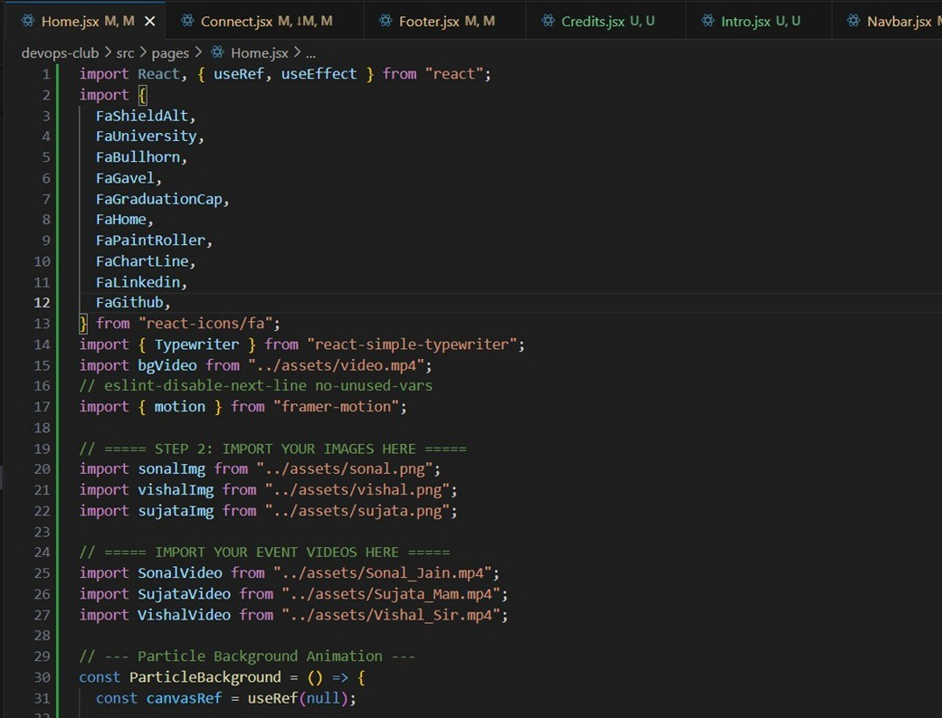

Figure 5.1: Home Page

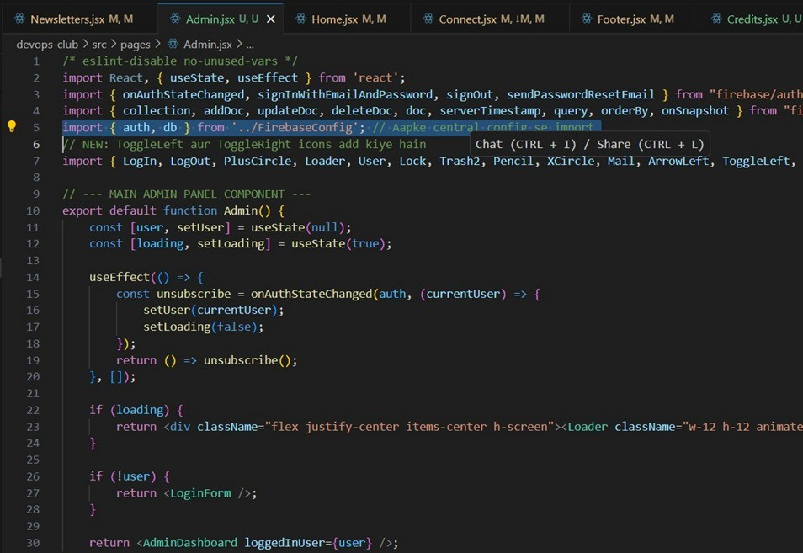

Figure 5.2: Admin Panel

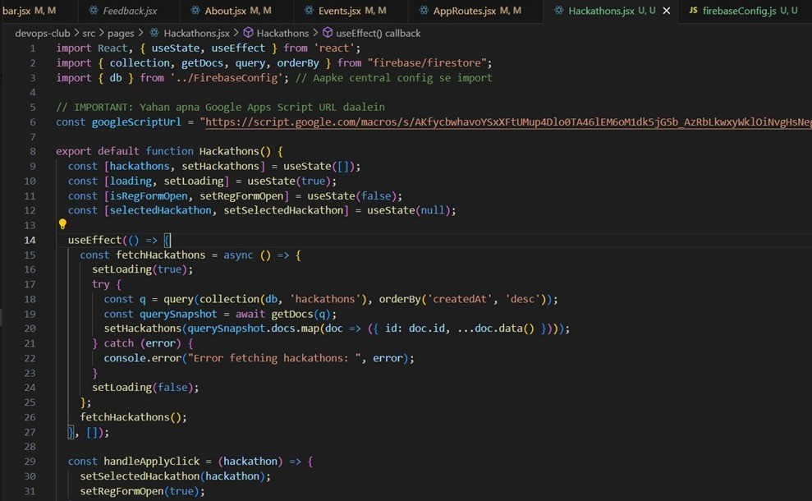

Figure 5.3: Hackathon Page

# Chapter 6

**Project Scheduling**

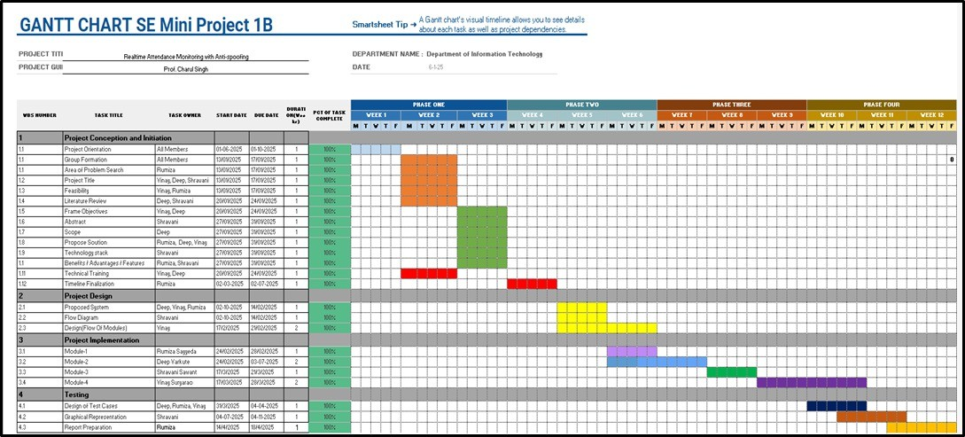

Figure 6.1: Project Scheduling

# Chapter 7 Results



Figure 7.1: Home Page

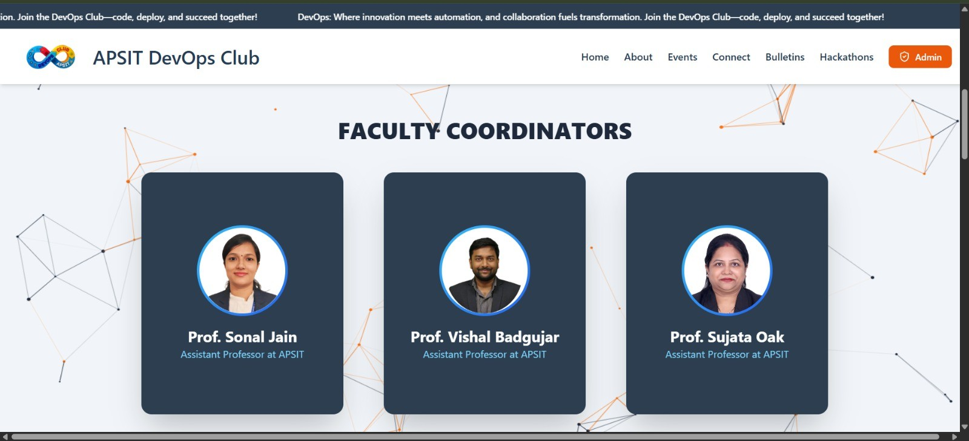

Figure 7.2: Home Page - Faculty Coordinators

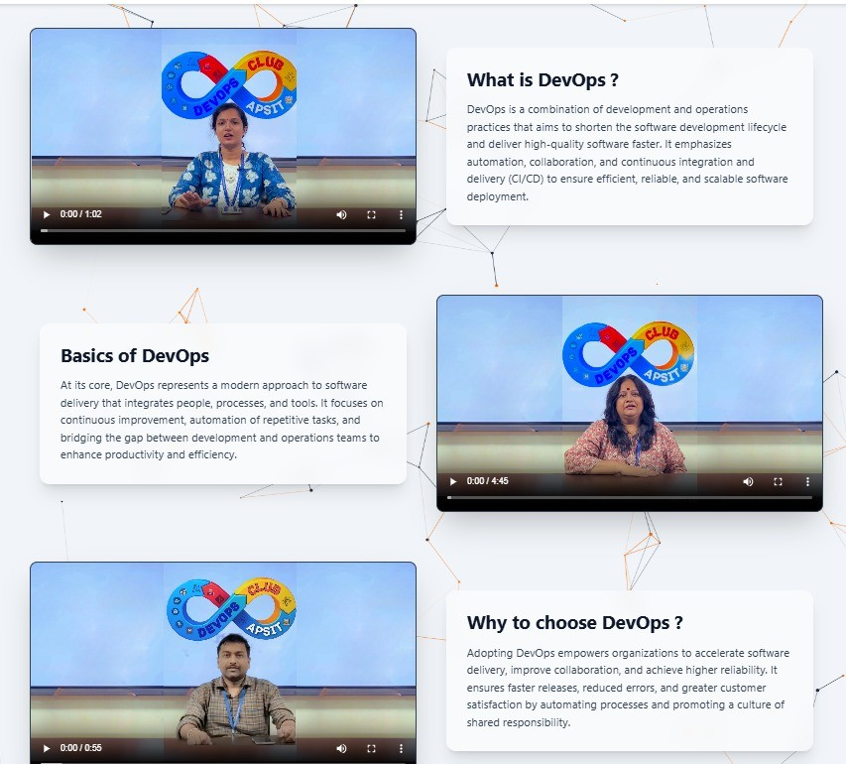

Figure 7.3: Home Page - Discover DevOps

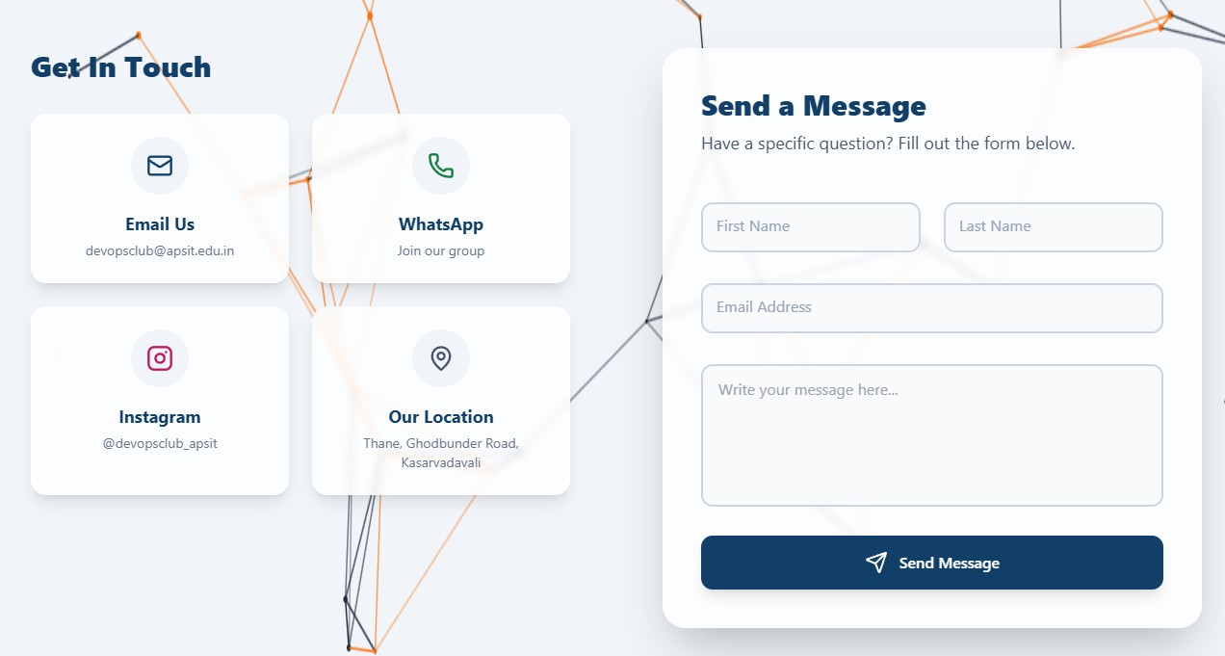

Figure 7.4: Connect Page



Figure 7.5: Bulletins Page

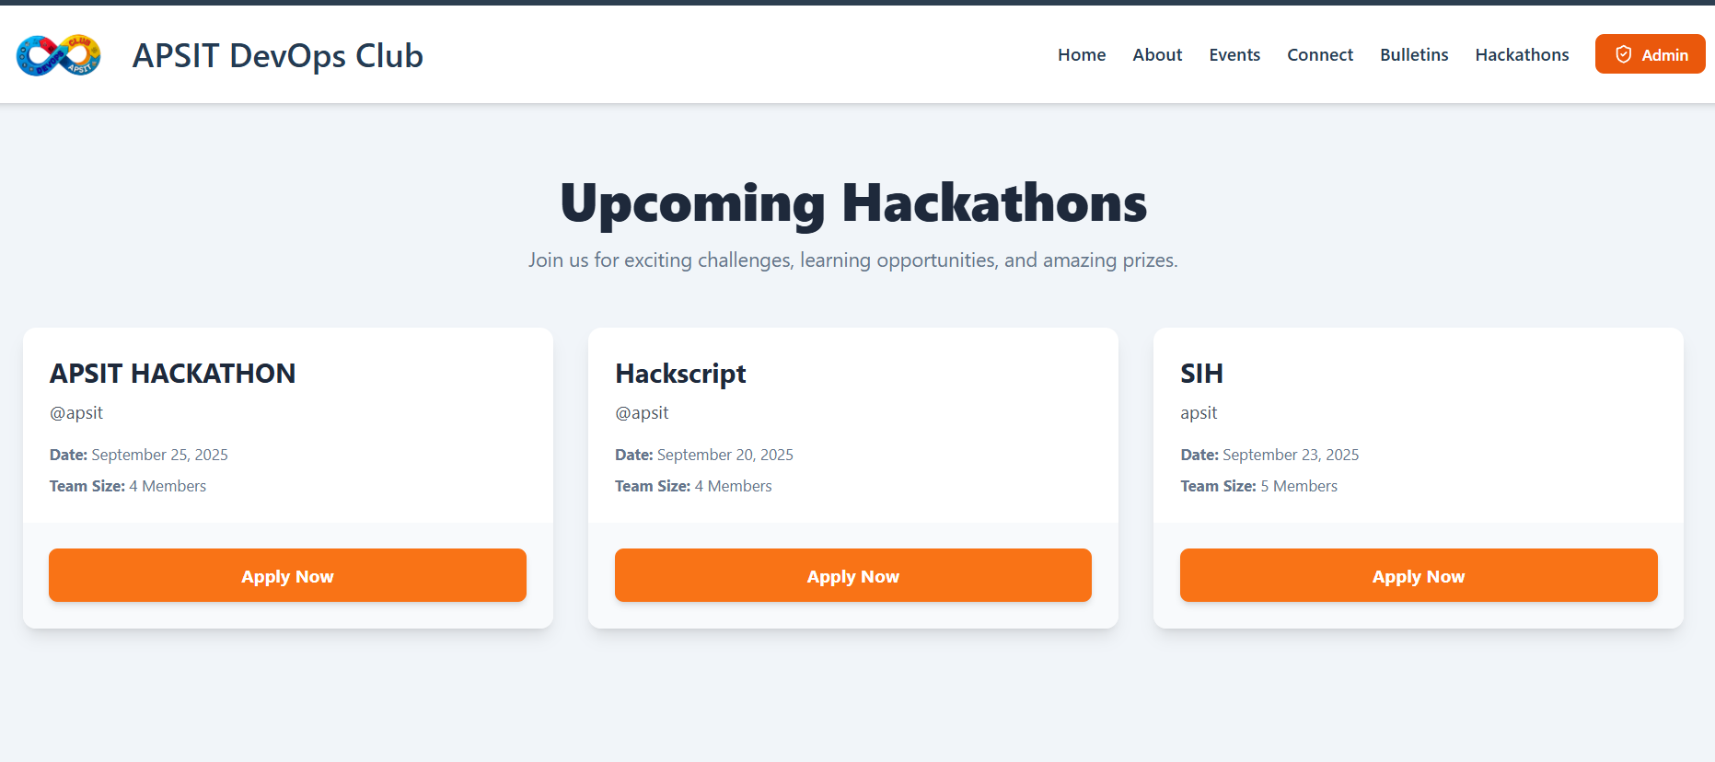

Figure 7.6: Hackathons Page



Figure 7.7: Admin Page - Admin Login



Figure 7.8: Admin Page - Manage Event

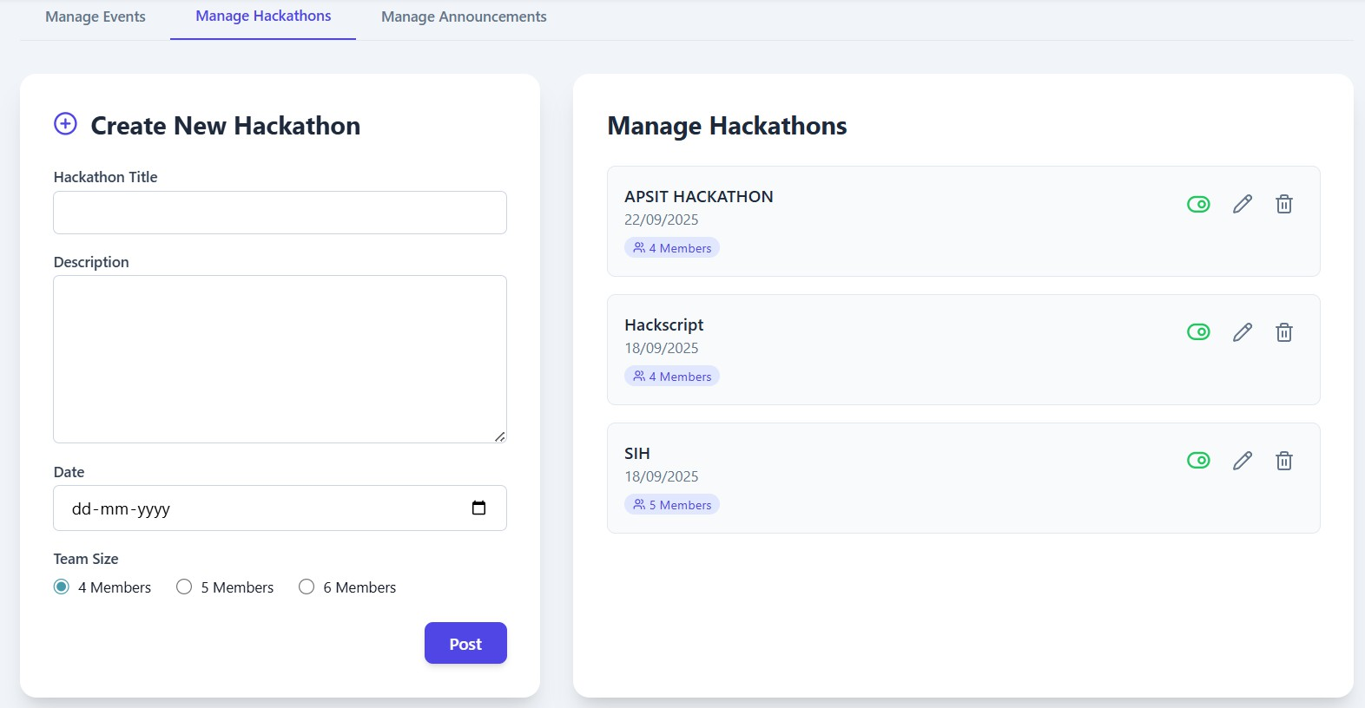

Figure 7.9: Admin Page - Manage Hackathons



Figure 7.10: Admin Page - Manage Announcements



Figure 7.11: Footer



Figure 7.12: Website Credits

# Chapter 8 Conclusion

The APSIT DevOps Club plays a key role in connecting academic theory with industry practice. However, it faces major operational challenges because there is no central digital platform. This lack of centralization leads to poor communication, lengthy manual processes for managing events, and a chaotic knowledge base. These issues make the experience disjointed for members and hinder the club’s ability to demonstrate their skills and projects effectively.

The proposed ”APSIT DevOps Club Web Platform” tackles these challenges by creating a single digital space for all club activities. It includes key features like a lively events and hackathon system, a main bulletin board, a resource library, and an admin panel. The plat- form will simplify operations and encourage a culture of ongoing improvement. In the end, this platform will act as a digital incubator. It will help students work together on projects, gain practical experience with industry tools, and develop a strong portfolio. This way, they will be well-prepared to become future leaders in the software industry.

# Chapter 9 Future Scope

* In the future, there may be direct integration with the A. P. Shah Institute of Tech- nology’s official Enterprise Resource Planning (ERP) system. This would make the process of checking students’ identities during registration automatic, making sure that all members are current students. It could also sync club events with the official college calendar, which would make them more visible on campus.
* It would be better if the project hub worked more closely with platforms like GitHub. This would let you see how the project is going in real time right on the platform, automatically show code commits and contributions on member profiles, and make it easier for teams to work together.
* A separate module could be made to connect current students with club alumni who are now working in the field. This feature would make it easier to set up a mentorship program where junior members could get career advice and help from more experi- enced professionals. This would make the connection between academia and industry stronger.

# References

1. Quality-Aware DevOps research: where do we stand? https://ieeexplore.ieee.org/document/9373305
2. DevOps: A Historical Review and Future Works
3. h[ttps://www.devopsmalnad.com/index](http://www.devopsmalnad.com/index)
4. https://brandemic.in/